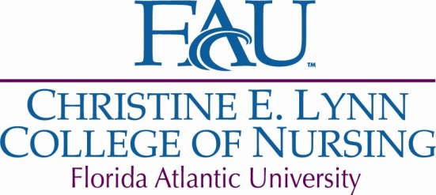
Christine E. Lynn College of Nursing – PhD Program

Comprehensive Exam Planning Form

Student Name: __________________________________ Date: ______________

Propose 3 possible topics for your manuscript:
1
2
3

List your chair (not your dissertation chair) and at least one potential member/reader. It is possible that different members will be selected by the PhD Committee. It is recommended that one of your comprehensive exam committee members be your future dissertation chair.

Comprehensive Exam Chair
First member/reader
Second member/reader

Return form to the Office of Nursing Research, Scholarship, and PhD Studies (located in Suite 215).

Revised 2/10/17

